Functions & VIEWS

# 1) Calculate Total Sales

## 1.1. fn_CalculateTotalSales

#### Purpose

Calculates the total amount spent by a customer on all transactions.

#### Inputs & Returns

Input - CustomerID (INT) - The ID of the customer.

Return - The total amount spent by the customer.

#### A screenshot of a computer Description automatically generatedCode & Output Results

# 2) Calculate Product Sales

## 2.1. fn_CalculateProductSales

#### 2.1.1. Purpose

#### Calculates the total sales for a given product.

#### 2.1.2. Inputs & Returns

Input - ProductID (INT) - The ID of the product.

Return - DECIMAL - The total sales for the product.

#### 2.1.3. Code & Output Results

# 3) Get Product Availability

## 3.1. fn_GetProductAvailability

#### 3.1.1. Purpose

Returns the available quantity of a product in a specific warehouse.

#### 3.1.2. Inputs & Returns

Inputs - ProductID (INT) - The ID of the product.

WarehouseID (INT) - The ID of the warehouse.

Return - The available quantity of the product in the warehouse.

#### 3.1.3. Code & Output Results

# 4) Get Discounted Price

## 4.1. fn_GetDiscountedPrice

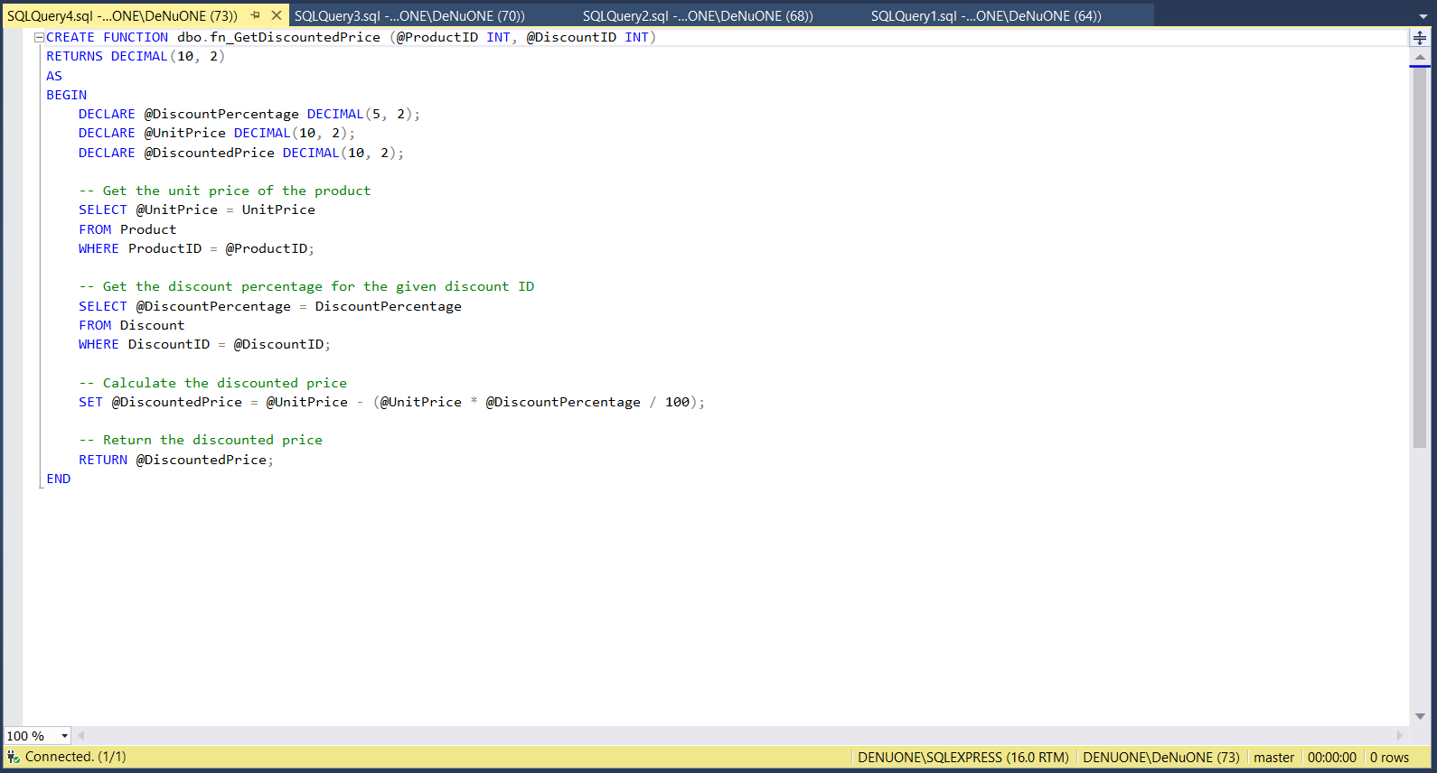

#### 4.1.1. Purpose

Calculate the price of a product after applying for a discount.

#### 4.1.2. Inputs & Returns

Inputs – ProductID (INT) - The ID of the product.

DiscountID (INT) - The ID of the discount to be applied.

Return - The discounted price of the product.

#### 4.1.3. Code & Output Results

**VIEWS**

# 5) Customer Sales Summary

## 5 .1. vw_CustomerSalesSummary

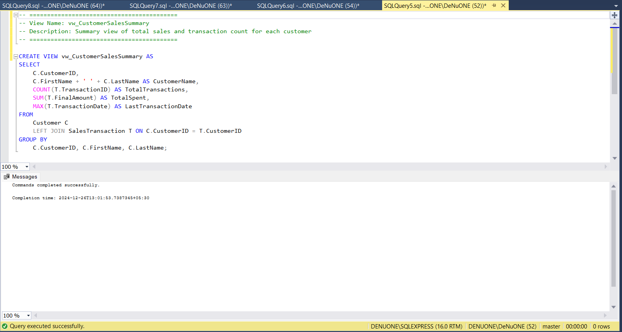

#### 5.1.1. Purpose

Summary view of total sales and transaction count for each customer.

#### 5.1.2. Code & Output Results

# 6) Product Sales Overview

## 6.1. vw_ProductSalesOverview

#### 6.1.1. Purpose

Provides an overview of products with total sales and current stock.

#### 6.1.2. Code & Output Results

# 7) Employee Role Summary

## 7.1. vw_EmployeeRoleSummary

#### 7.1.1. Purpose

Provides employees with details along with their roles and contact info.

#### 7.1.2. Code & Output Results

# 8) Sales Transaction Details

## 8.1. vw_SalesTransactionDetails

#### 8.1.1. Purpose

Provides details of each sales transaction, including product info.

#### 8.1.2. Code & Output Results